Case Study: New data perspectives

As you’ve been learning, you can find data pretty much everywhere. Any time you observe and evaluate something in the world, you’re collecting and analyzing data. Your analysis helps you find easier ways of doing things, identify patterns to save you time, and discover surprising new perspectives that can completely change the way you experience things.

Here’s a real-life example of how one group of data analysts used the six steps of the data analysis process to improve their workplace and its business processes. Their story involves something called people analytics — also known as human resources analytics or workforce analytics. People analytics is the practice of collecting and analyzing data on the people who make up a company’s workforce in order to gain insights to improve how the company operates.

Being a people analyst involves using data analysis to gain insights about employees and how they experience their work lives. The insights are used to define and create a more productive and empowering workplace. This can unlock employee potential, motivate people to perform at their best, and ensure a fair and inclusive company culture.

The six steps of the data analysis process that you have been learning in this program are:

**ask, prepare, process, analyze, share,** and **act**. These six steps apply to any data analysis. Continue reading to learn how a team of people analysts used these six steps to answer a business question.

An organization was experiencing a high turnover rate among new hires. Many employees left the company before the end of their first year on the job. The analysts used the data analysis process to answer the following question:

how can the organization improve the retention rate for new employees?

Let’s break down what this team did, step-by-step.



First up, the analysts in our example needed to define what the project would look like and what would qualify as a successful result. So, to determine these things, they **asked** effective questions and collaborated with leaders and managers who were interested in the outcome of their people analysis.

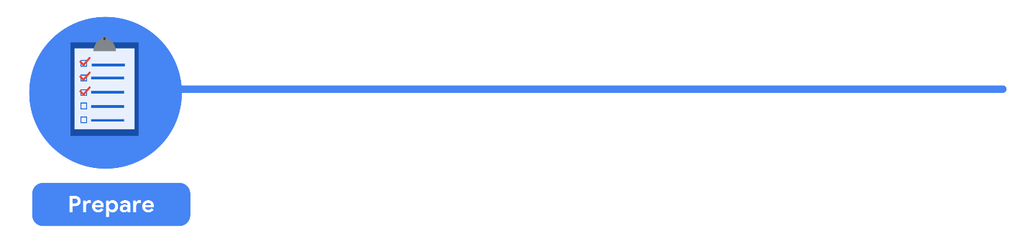

It all started with solid **preparation**. The group built a timeline of three months and decided how they wanted to relay their progress to interested parties. Also, during this step, the analysts identified what data they needed to achieve the successful result they identified in the previous step - in this case, the analysts chose to gather the data from a survey of new employees. They identified specific questions to ask about employee satisfaction with different business processes, such as hiring, onboarding, and compensation. Rules were established for who would have access to the data collected, what specific information would be gathered, and how best to present the data visually. The analysts brainstormed possible project- and data-related issues and how to avoid them.

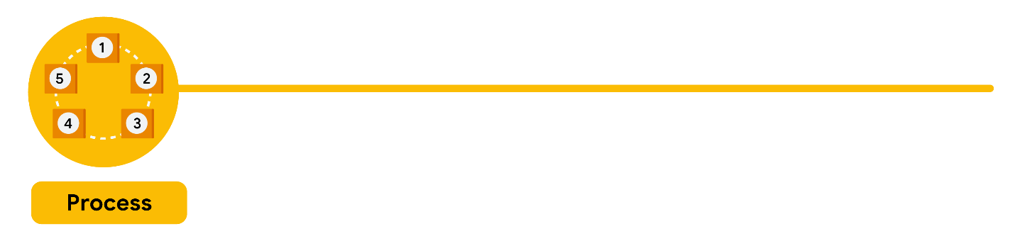

The group sent the survey out. Great analysts know how to respect both their data and the people who provide it. Since employees provided the data, it was important to make sure all employees gave their consent(permission) to participate. The data analysts also made sure employees understood how their data would be **collected, stored, managed, and protected**. In order to maintain confidentiality and protect and store the data effectively, access was restricted to a limited number of analysts. Collecting and using data ethically is one of the responsibilities of a data analyst. Then the data was cleaned up to make sure it was complete, correct, and relevant, and uploaded to an internal data warehouse for an additional layer of security.

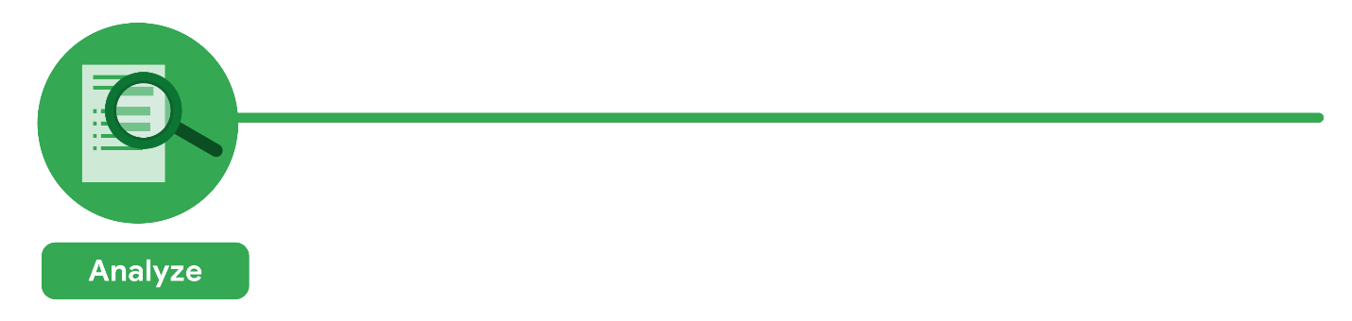

Then, the analysts did what they do best:

analyze! From the completed surveys, the data analysts would **discover** that a new employee’s experience with the hiring process was a key indicator of overall job satisfaction. The analysts found that employees who experienced an efficient and transparent hiring process were most likely to remain with the company. Employees who experienced a long and complicated hiring process were most likely to leave the company. The group knew it was important to **document** exactly what they found in the analysis, no matter what the results. To do otherwise would decrease trust in the survey process and reduce their ability to collect truthful data from employees in the future.



Just as they made sure the data was carefully protected, the analysts were also careful **sharing the report**. For example, in order for a manager to receive the survey report, a minimum number of their team members had to have participated in the survey. The group presented the results to leaders first to make sure they had the full picture, then asked them to deliver the results to their teams. This gave leaders an opportunity to **communicate the results** with the right context and have productive team conversations about next steps.

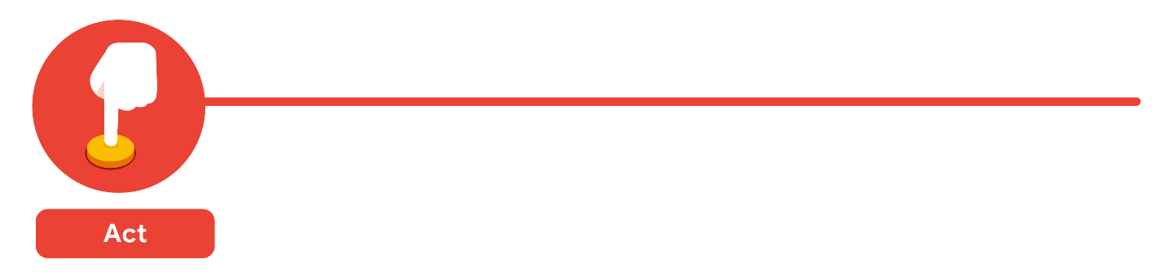

The last stage of the process for the team of analysts was to work with leaders within their company and decide how best to **implement changes and take actions** based on the findings. The analysts recommended standardizing the hiring process for all new hires based on the most efficient and transparent hiring practices. A year later, the same survey was distributed to employees. Analysts anticipated that a comparison between the two sets of results would indicate that the action plan worked. Turns out, the changes improved the retention rate for new employees and the actions taken by leaders were successful!

## **Is people analytics right for you?**

One of the many things that makes data analytics so exciting is that the problems are always different, the solutions need creativity, and the impact on others can be great — even life-changing or life-saving. As a data analyst, you can be part of these efforts. Maybe you’re even inspired to learn more about the field of people analytics. If so, consider learning more about this field and adding that research to your data analytics journal. You never know: One day soon, you could be helping a company create an amazing work environment for you and your colleagues!

## **Additional Resource**

To learn more about some recent applications of data analytics in the business world, check out the article [“3 Examples of Business Analytics in Action”](https://online.hbs.edu/blog/post/business-analytics-examples) from Harvard Business School.  The article reveals how corporations use data insights to optimize their decision-making process. Please note that the first example in the article contains a minor error in the second paragraph, but the example is still a valid one.

Correction to article in bold below: Microsoft’s Workplace Analytics team hypothesized that moving the 1,200-person group from five buildings to four could improve collaboration by **increasing** the number of employees per building and by reducing the distance that staff needed to travel for meetings.